A PROJECT REPORT

ON

**“School Bus Management System”**

SUBMITTED BY

**Ankush Supekar**

UNDER THE GUIDANCE OF

**PROF. Vishakha Tambe**

IN PARTIAL FULFILLMENT OF THE REQUIREMENT OF THE DEGREE

BACHELOR OF COMPUTER SCIENCE

PRESENTED TO

**H.V.DESAI COLLEGE PUNE-411002**

**(2017-2018)**

**Acknowledgement**

It gives a great pleasure to present this seminar report on “Library Management system” and would like to take the opportunity to thank everyone. I want to thank the college for giving me this great opportunity to present my project in front of you all.

I express my profound gratitude and sincere thanks to my project guide Ms. Vishakha Tambe for her constant guidance and encouragement without co-operation of whom this seminar would hardly been a success. I would also like to pay a special word of thanks for always keeping all the things going smoothly for us in the department.

* Ankush Supekar ROLLNO.
* ROLLNO.

**INDEX**

1. About the system
2. Problem Definition
3. Scope of the system
4. Feasibility study

* Technical Feasibility
* Economic Feasibility
* Operational Feasibility

1. Finding Fact Techniques

* Interview Questionnaires
* Review

1. Data Normalization

* ERD
* Data Dictionary

1. UML Diagram

* Use Case Diagram
* Sequence Diagram
* Activity Diagram
* Deployment Diagram
* Collaboration Diagram

1. I/O Screens
2. Limitations and Future enhancement of system
3. Bibliography

**ABOUT THE SYSTEM**

We are developing a system for Managing the School Bus Databases where parents & System admins can keep tracks on Pick up Timings of Student on daily Basis and also track vehicle Location. Registered Drivers are also gets his bus number, route information, and pick up Points of each student.

Student Must be a Registered with School and also applied for the bus Service, Only the bus member students data will be tracked on the system, Driver must update status at each pick up point.

Parents must pay the monthly fees for Continuation of their service each month.

Hardware Requirements:

* Server Machine : RAM 256 MB
* Client Machine

Software Requirements:

* Windows Operating Systems
* Wamp Server

Modules:

* Parents
* Admin
* Driver

**PROBLEM DEFINITION**

* Existing system was manual
* Time consuming as data entry which include calculations took lots of time.
* Searching was very complex as there could be hundreds of entries every year.
* The proposed system is expected to be faster than the existing system.
* The project was made in order to effectively and efficiently cater to requirements of the fitness center. Very frequently the person who generally holds the tasks to manage the center, needs to keep records of all the transactions as well as data manually. Generally, in order to structure these tasks separate registers are maintained. This whole process thus becomes quite challenging for them to control manually. Moreover, any wrong date entered mistakenly can bring serious results.
* This manually managed system of the store was also heavily prone to data loss due to certain causes like misplacement of registers, destruction of registers, unauthorized access to registers etc. which can bring in problematic consequences.
* Searching a particular data specific to particular requirements is also very tedious in such system. In order to retrieve records, the responsible person needs to manually locate the appropriate register and locate the appropriate placement of that particular record which maybe very time consuming.
* Data redundancy is also a great issue in such kind of system. “Redundancy” means repetition; thus data modified or updated at a particular place may not be data modified or updated at the other related place which may create inconsistencies in data handling which destroys data integrity and creates confusion for the owner.

**Requirement analysis:**

* **System analysis** refers into the process of examining a situation with the intent of improving it through better procedures and methods. System analysis is the process of planning a new system to either replace or complement an existing system. But before any planning is done the old system must be thoroughly understood and the requirements determined. System analysis, is therefore, process of gathering and interpreting facts, diagnosing problems and using the info. to re-comment improvements in the system. Or in other words system analysis means a detailed explanation or description. Before computerized a system under consideration, it has to be analyzed. We need to study how it functions currently, what are the problems, what are the requirements that the proposed system should meet.
* System analysis is conducted with the following objectives in mind:

Identify the customer’s need.

Evaluate the system concept for feasibility. Perform economic and technical analysis.

Allocate functions to hardware, software people, database and other system elements.

Establish cost and schedule constraints.

Create a system definition that forms the foundation for all the subsequent engineering work.

Fulfill all of its current as well as future requirements. Further more, data handling was also posing a serious problem for them.

**Existing System**

When we analyze the management about this firm then we face that they are working manually. And we all know that the manual system has many disadvantages. Some are mentioned below:

* Manual system requires more time for processing.
* It requires more critical work.
* Manual system is more error prone.
* Difficult to maintain.
* Manual system is costly.
* Immediate response to the queries is difficult and time consuming.
* More men power needed.

**Feasibility Study**

* Depending on the result of the initial investigation, the survey is expanded to a more detailed feasibility study. Feasibility study is a test of system proposal according to its workability, impact on the organization, ability to meet user needs, and effective use of resources. Objective of the feasibility study is not to solve the problem but to acquire a sense of its scope. During the study, the problem definition is crystallized and aspects of the problem to be included in the system are described with greater accuracy at this stage.

1. **Technical Feasibility:**

* Technical feasibility centers around the existing comp. system and to what extent it support the proposed addition. For ex, if current comp. is operating at 80 % capacity-an arbitrary ceiling-then running another app. could overload the system or require additional hardware. This involves financial considerations to accommodate technical enhancements. If the budget is serious constraint, then project is judged not feasible. In this project, all necessary cautions have been taken care to make it technically feasible. Using a key the display of text/object is very fast. Also the tools, operating system and programming lang. used in this localization process is compatible with the existing one.

1. **Economical Feasibility**

* Economic analysis is the most frequently used method for evaluating the effectiveness of the candidate system. More commonly known as cost/benefit analysis, procedure is to be determining the benefits and savings that are expected from a candidate and compare them with costs. If benefits outweigh costs, then decision is made to design implement the system.
* A systems financial benefit must exceed the cost of developing that system, i.e. a new system being developed should be a good investment for the organization. Economic feasibility considers following:
* The cost to conduct a full system investigation.
* The cost of hardware and software for the class of application.
* The benefits in the form of reduced costs or fewer costly errors.
* The cost if nothing changes (i.e. the proposed system is not developed).
* The proposed system is economically feasible because:
* System requires very less time factors.
* The system will provide fast and efficient automated environment instead of slow and error prone manual system, thus reducing both time and manpower spent in running the system.
* System will have GUI Interface and very less user training is required to learn it.
* System will provide service to view various info. if required for some decision making.

1. **Operational Feasibility:**

* This app. is very easy to operate as it is made user friendly with help of very effective GUI tools. Main consideration is user’s easy access to all the functionality of the app. Another main consideration is that whether user organization is trained enough to use the newer app. Here functionality is as per previous operational strategy which is not expected to be difficult to the potential clients.

**Fact Finding Techniques**

* To study any system the analyst needs to collect fact and all relevant info. The facts when expressed in quantitative form are termed as data.
* The success of any project is depended upon accuracy of available data. Accurate info. can be collected with help of certain methods. These specific methods for finding info. of the system are termed as fact finding techniques.
* Fact finding technique is a formal process to collect info. about the system requirements. Fact finding techniques are basically used for finding and knowing the fact how the system works as well as to gather the info.
* These include:
* Interview
* Questionnaires
* Record Review
* Observation

**Interview**

In our app. we interviewed many customers. We asked them the problems they exactly faced regarding registration, their needs regarding products, quantity of products and gave them info about products and price. This phase was very helpful in deciding scope.

**Questionnaires**

It is the technique used to extract info from no. of customers. The questionnaire consists of series of questions framed together in logical manner. The questions are simple, clear and to the pt. For our app. we met customers and teachers and asked different questions regarding requirement and products.

**Record Review**

In order to decide flow of our project we went through records maintained by the staff, customers, products, orders and we got to know what we exactly need to do.

**Observation**

We have observed how process works; problem in manual system forced us to design computerized application.

**Data Dictionary**

**Table 1: Club Table**

|  |  |  |  |  |
| --- | --- | --- | --- | --- |
| **Sr. no** | **Field Name** | **Data type** | **Key Status** | **Description** |
| **1** | **C_id** | **Int** | **Primary** | **Clubing ID** |
| **2** | **C_name** | **Varchar(20)** | **Not null** | **Clubing Name** |

**Table 2: Student Table**

|  |  |  |  |  |
| --- | --- | --- | --- | --- |
| **Sr. no** | **Field Name** | **Data type** | **Key Status** | **Description** |
| **1** | **S_id** | **Int** | **Primary Key** | **Student_id** |
| **2** | **S_name** | **Varchar(30)** | **Not Null** | **Student Name** |
| **3** | **Contact** | **Int** | **Not Null** | **Mobile Number** |
| **4** | **Address** | **Varchar(50)** | **Not Null** | **Address** |
| **5** | **C_id** | **Int** | **Foreign key**  **Club(C_id)** | **Club ID** |
| **6** | **Pick_up_Location** | **Varchar(30)** | **Not Null** | **Pick-up location** |

**Table 3: Driver Table**

|  |  |  |  |  |
| --- | --- | --- | --- | --- |
| **Sr. no** | **Field Name** | **Data type** | **Key Status** | **Description** |
| **1** | **D_no** | **Int** | **Primary key** | **Driver Number** |
| **2** | **D_name** | **Varchar(20)** | **Not null** | **Driver Name** |
| **3.** | **Address** | **Varchar(50)** | **Not null** | **Address** |
| **4.** | **Contact** | **Int** | **Not null** | **Mobile number** |
| **5** | **License_no** | **Int** | **Not null** | **License Details** |

**Table 4: Clubing Table**

|  |  |  |  |  |
| --- | --- | --- | --- | --- |
| **Sr. no** | **Field Name** | **Data type** | **Key Status** | **Description** |
| **1** | **Bus_no** | **Int** | **Not null** | **Bus Number** |
| **2** | **C_id** | **Int** | **Foreign Key**  **Club(C_id)** | **Clubbing ID** |
| **3** | **S_id** | **Int** | **Foreign Key**  **Student(S_id)** | **Student_id** |
| **4** | **D_id** | **Int** | **Foreign Key**  **Driver(D_id)** | **Driver ID** |
| **5** | **Date** | **Date** | **Not null** | **Clubing Day Date** |

**Table 5: Student_leave Table**

|  |  |  |  |  |
| --- | --- | --- | --- | --- |
| **Sr. no** | **Field Name** | **Data type** | **Key Status** | **Description** |
| **1** | **S_id** | **Int** | **Foreign Key**  **Student(S_id)** | **Student ID** |
| **2** | **Leave_date** | **Date** | **Not null** | **Leave date** |

**Table 6: Driver leave Table**

|  |  |  |  |  |
| --- | --- | --- | --- | --- |
| **Sr. no** | **Field Name** | **Data type** | **Key Status** | **Description** |
| **1** | **D_id** | **Int** | **Foreign Key**  **Driver(D_id)** | **Driver ID** |
| **2** | **Leave_Date** | **Date** | **Not null** | **Leave date** |

**DATA NORMALIZATION**

**ER Diagram**

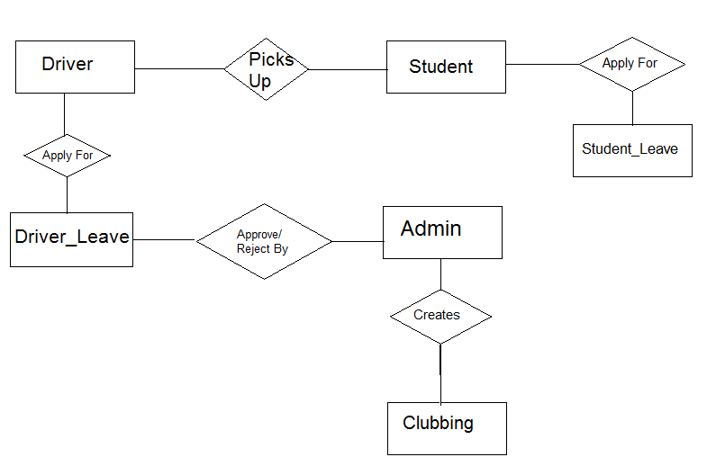

**Class Diagram:**

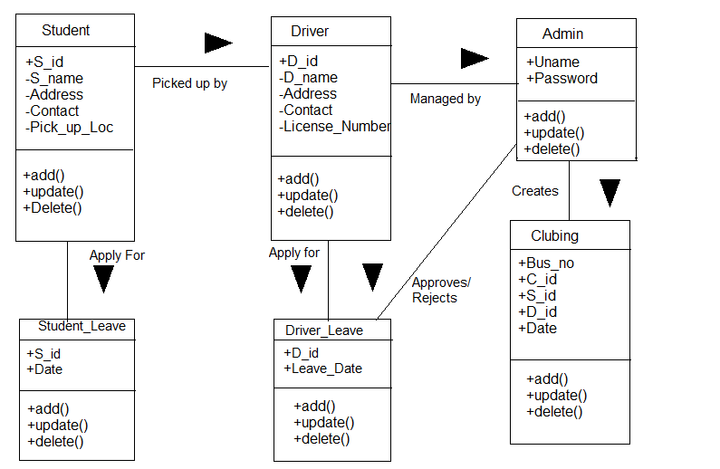

Student

Admin

Driver

School Bus Management System

**Deployment Diagram**

DBMS

Web Server

Client machine

HTTP MySQL query

**Component Diagram**

Find.html

page

Find.exe

index.html

executable

<<hyperlinks>>

Dbacs.dll

Component library

**Testing Techniques**

Software testing is used to evaluate quality of work performed at each step of software development. The purpose of software testing is to ensure that software performs intended task to give quality assurance.

It includes three things to be done:

* Verification
* Validation
* Reliability

In short software performs this tasks to improve software quality, reliability and maintainability.

The goal of testing is to find errors. The core mission of tester and test team is to exercise the product in a way that will examine customer satisfaction. The tester will actually exercise the product and then verify it is fit to run in all possible ways. The testing implemented for the software should find out maximum errors in minimum efforts.

* **A strategic approach for software testing**

Testing is a set of activities that can be performed in advance and conducted systematically.

* **Testing should be carried out by keeping the following points in mind**

To perform effective testing, a software team should conduct effective technical review. By this many errors will be eliminated before testing commences.

Testing begins at the component level and works outward towards the integration of the entire computer-based system.

Testing and debugging is different activities, but debugging must be accommodated in a way of testing strategy.

A strategy for software testing must be accommodated low level tests that are necessary to verify that a small source code segment has been correctly implemented as well as high level tests that validate major system function against customer requirement.

**Types of testing:**

* White-box testing
* Black-box testing

**White box testing:**

It is close examination of procedural logic. Logical paths are tested by providing test cases that exercise specific to set of conditions and loops. Test cases are derived as:

* All independent paths within a module have been exercised at least once.
* All logical decisions are exercised on their true and false sides.
* All loops are executed at their boundaries and within their operational bounds.
* All internal data structures are exercised to ensure their validity.

**Black box testing:**

It is conducted at software interface. It demonstrates that software functions are operational, input is properly accepted and output is correctly produced and integrity of external info is maintained. It examines some fundamental aspects with little regard for internal logic structure of the software. It has been tested to find errors such as:

* Incorrect or missing function
* Interface errors.
* Errors data structures or external database access.
* Behavior or performance errors.
* Initialization and termination errors

**Limitations**

The Access to books is limited to Students of particular college. The Student cannot pay Fine online.

**Future Enhancement**

**There is always a scope for improvement in any system.**

In our system, the things which can be improved are as follows:

* Any Student Can become library member by paying a MemberShip fee.
* We would try to accept payments online to ease for external Students.

**Bibliography**

While analyzing this system we referred following books:

* **Programming in Java-I**  Nirali Publications.
* **Programming in Java-II** Nirali Publications.

We referred following websites:

* [www.google.com](http://www.google.com)
* www.w3schools.com

Whereas all above mentioned PHP books & Websites have been proved very useful while coding for the system.